External Partner Management Portal – Project Plan

Executive Summary
Develop a minimalistic partner management portal to register and review external business partners for Dr. Reddy’s. The portal will allow employees to create partner profiles (name, contact, organization, category, etc.), submit them for approval, and allow reviewers to approve or reject. We will use an ASP.NET Core Web API (C#) backend with a SQLite database, and a React + TypeScript frontend. AI-assisted features (like category suggestions or address normalization) will be integrated for better data quality. The solution follows Dr. Reddy’s Third-Party compliance standards (e.g. data privacy and ethical conduct【29†L999-L1001】【5†L91-L100】). It will be designed end-to-end so that Copilot/Antigravity can generate code scaffolding and tests, but remain simple enough to discuss and extend.

Project Goals
- Streamline partner onboarding: Provide a web portal to create, track, and approve external partner profiles.
- Ensure compliance: Capture necessary partner info (e.g. due diligence data) and enforce validation/rules per Dr. Reddy’s policies【29†L999-L1001】【28†L109-L112】 (e.g. no duplicate emails, valid contact info, etc.).
- Auditability: Record all submissions and decisions for traceability (logging who approved/when).
- AI assistance: Use AI (via Copilot or an LLM) to auto-suggest fields (categories, address formatting, etc.) and improve UX.
- Developer productivity: Use Copilot/Antigravity to generate boilerplate code, enabling a quick PoC and easier explanation of design choices.

Target Users & Roles
- Employee (Partner Initiator): Company employees (e.g. procurement/business managers) who enter new partner information. They can create or edit partner drafts and submit for review.
- Reviewer (Approver): Compliance or procurement reviewers who approve or reject submitted partners. They can view partner details, comment, and change status.
- (Optional) Admin: If needed later, a super-user to manage categories or system settings. Note: For MVP, we assume no separate login; roles can be chosen via a dropdown or dev mode.

Tech Stack (chosen for simplicity and developer familiarity)
- Backend: ASP.NET Core 8 Web API (.NET 8, C#). Enterprise-grade, cross-platform, with built-in security features. EF Core for ORM.
- Database: SQLite. Lightweight, file-based (no setup), ideal for a demo. Can switch to SQL Server later if needed.
- Frontend: React (with Vite) and TypeScript. Modern component-based UI for quick development. (Blazor or plain HTML/CSS could work, but React is more common.)
- AI/ML: Leverage OpenAI (GPT-4 or similar) via Azure OpenAI or REST calls for prompts. For example, prompt a model to suggest categories or normalize addresses. Running on the server side is preferred (to hide API keys and handle heavy logic). Use simple fallback behavior (e.g. static default suggestions or errors) if AI is unavailable.
- Hosting: For a quick showcase, we can deploy the frontend on a free host (e.g. Vercel or Netlify) and the .NET API on a free tier (Azure App Service free tier, or a service like Railway). This requires minimal setup and demonstrates a live prototype.

Architecture
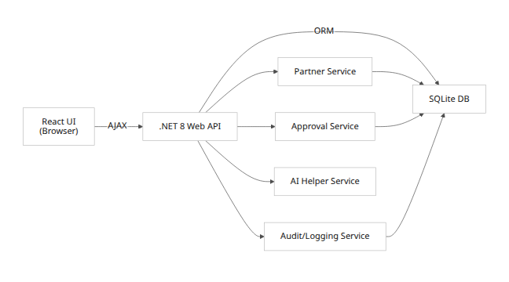
- The React UI makes HTTP calls to the ASP.NET Core backend.
- Services (PartnerService, ApprovalService, etc.) contain business logic.
- The AIService handles calls to an AI model (e.g. OpenAI) for tasks like category suggestion.
- The database (SQLite) stores Partner records, history, and audit logs.

Services / Components
- Partner Controller / Service: CRUD operations for partner records. Handles status transitions (draft → submitted → approved/rejected).
- Approval Controller / Service: Endpoints for approving, rejecting partners (changing status, adding comments).
- Audit/History Service: Records changes (submissions, approvals, rejections) with user and timestamp.
- AI Helper Service: Exposes APIs like GET /ai/suggest-categories?input=xyz using a language model; called by frontend during data entry.
- Frontend Components:
- PartnerListPage: search/filter partners, view status.
- PartnerFormPage: create/edit partner with validation.
- PartnerReviewPage: show partner details and history, approve/reject buttons (visible to Reviewer role).
- Shared Header/Footer and role-selection (if no auth).

Database Schema
Table | Column | Type | Constraints / Notes
Partners | Id | INTEGER (PK) | Auto-increment
 | Name | TEXT | NOT NULL
 | Email | TEXT | NOT NULL, UNIQUE(?)* [pattern enforced]
 | Phone | TEXT | [e.g. 10 digits, format validated]
 | Organization | TEXT
 | Category | TEXT | (e.g. “Medical”, “Distributor”)
 | Address | TEXT | Full address (city, state, country)
 | Status | TEXT | Enum: Draft, Submitted, Approved, Rejected
 | CreatedBy | TEXT | (Username or role)
 | CreatedDate | DATETIME
 | UpdatedDate | DATETIME
ApprovalHistory | Id | INTEGER (PK)
 | PartnerId (FK→Partners) | INTEGER
 | OldStatus | TEXT
 | NewStatus | TEXT
 | Comment | TEXT
 | ChangedBy | TEXT
 | ChangedOn | DATETIME
AuditLog | Id | INTEGER (PK)
 | PartnerId (FK) | INTEGER | Nullable (some logs may be global)
 | Action | TEXT | (e.g. “Created”, “Submitted”)
 | User | TEXT
 | Timestamp | DATETIME
 | Metadata (JSON) | TEXT | (Optional additional info)
* Unique email constraint is optional (if multiple partners share an email), but at least use a regex check.

API Design
Endpoint | Method | Description | Request Body (JSON) | Response | Status Codes
GET /api/partners | GET | List all partners (with filters) | (optional query: status/category) | List of partners | 200 OK, 204 No Content
GET /api/partners/{id} | GET | Get details of one partner | — | Partner object | 200 OK, 404 Not Found
POST /api/partners | POST | Create new partner (status=Draft) | Partner DTO (Name, Email, ...)* | Created partner (with Id) | 201 Created, 400 Bad Request
PUT /api/partners/{id} | PUT | Update existing partner (if Draft/Rejected) | Partner DTO | Updated partner | 200 OK, 400/404
POST /api/partners/{id}/submit | POST | Submit Draft for review (changes status) | (maybe comment) | Updated status | 200 OK, 400/404
POST /api/partners/{id}/approve | POST | Approve a Submitted partner | { comment: string } | New status | 200 OK, 400/404
POST /api/partners/{id}/reject | POST | Reject a Submitted partner | { comment: string } | New status | 200 OK, 400/404
GET /api/partners/{id}/history | GET | Get approval history for a partner | — | List of history entries | 200 OK
GET /api/partners/{id}/audit | GET | Get audit log entries for a partner | — | List of audit logs | 200 OK
GET /api/ai/suggest-categories?input=xyz | GET | (AI) Suggest categories for text input | — | { suggestions: [string] } | 200 OK, 500 Error
Fields in request DTOs should be validated. For example, Email must match a regex, Phone should be digits-only, and required fields (Name, Email, Category) must be present. Return 400 on validation errors (with messages). Use standard JSON error format.

UI Screens & Wireframes
- Partner List Page: Table of partners with columns (Name, Organization, Category, Status, Actions). Search box and filters by status/category. Action buttons: View/Edit and (if status=Submitted and user is Reviewer) Approve/Reject.
- Partner Form (Create/Edit): Form fields: Name, Email, Phone, Organization, Category (dropdown or free text with AI suggestions), Address (with AI normalize), etc. Buttons: Save Draft, Submit for Approval. Form shows validation errors inline.
- Partner Detail / Review Page: Display partner info in read-only mode, plus tabs or sections for “History” (list of previous status changes) and “Audit Log” (if implemented). If the current user is a Reviewer and status is Submitted, show Approve and Reject buttons with a comment box. Upon action, status changes with comment saved.
- Misc: A simple header with role selector (if no auth) and navigation. No fancy design needed – just clear layout (e.g. using Material-UI or plain CSS).
(No login screen is required for MVP; assume the user can choose a role.)

AI Features
We will include a couple of AI-assisted helpers to improve data entry and insights. Each feature can be triggered by an API call from the frontend.
- Category Suggestion: When the user types a partner organization or description, send a prompt to a GPT model like:
“Given the company description: ‘XYZ’, suggest 3 appropriate partner categories and explain them.”
The model (e.g. GPT-4 via Azure OpenAI) returns suggestions like “Healthcare Provider”, “Medical Distributor”, etc. These are shown in a dropdown for user to pick.
Model & Runtime: Azure OpenAI (server-side). Fallback: If API fails, show a few static category options or none.
- Address Normalization: Take a free-form address input and call an address/LLM normalization API (e.g. Google Geocoding or a GPT prompt: “Normalize this address: …”). Populate city/state fields automatically.
- Email Error Explanation: If email validation fails, use an AI to generate a helpful message (e.g. “The email seems missing a domain”). Could be done with a small heuristic or prompt to GPT.
- Audit Summary (optional): Generate a one-line summary of the partner’s approval history using an LLM to make logs human-readable (e.g. “Created by Alice, submitted on 7/10, approved by Bob on 7/12”).
- Copilot/Developer AI: During development, use GitHub Copilot or ChatGPT to scaffold code (controllers, React components, etc.) and create unit test templates.
All AI calls happen on the server side (so API keys stay secret). The frontend displays results or suggestions. If AI is unavailable, the feature degrades gracefully (e.g. no suggestion).

Workflow / State Machine
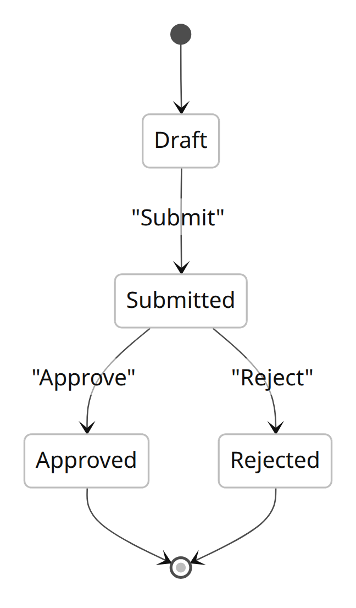
Partners start in Draft when created. The employee can edit until they Submit it, changing status to Submitted. A Reviewer then either Approves or Rejects it. (Optionally, a future flow could allow Reopen or Deactivate, but not in MVP.) Each transition is recorded in ApprovalHistory.

Security & Authentication
- Assumptions: No formal authentication system for MVP (per instructions). We assume internal use; roles are simulated (e.g. choose “Employee” or “Reviewer” in UI).
- Transport: Use HTTPS (if deployed) to encrypt data in transit.
- Data Protection: Comply with Dr. Reddy’s privacy policies【28†L109-L112】. Sensitive data (emails, etc.) is stored in the database with appropriate access controls (only backend code can read/write).
- Input Validation: Strictly validate inputs on the server (prevent SQL/Command injection by using parameterized EF Core queries). Sanitize any free-text fields.
- Error Handling: Do not expose stack traces or sensitive info in API errors. Log errors on the server (in AuditLog) without leaking details to the client.
- Note: In production, an auth system (e.g. Azure AD or LDAP) should be used. Roles (Employee vs Reviewer) would be enforced by identity/claims, and endpoints should be authorized accordingly.

Testing Strategy
- Unit Tests: For backend services (PartnerService, ApprovalService), write tests for:
- Creating a partner (valid vs invalid data)
- Submitting without required fields (should fail)
- Approving and rejecting (status changes, history logged)
- AI helper logic (mock AI API).
- API Tests (Integration): Using a tool like xUnit or Postman:
- POST /api/partners creates new partner.
- PUT /api/partners/{id} updates partner data.
- POST /api/partners/{id}/submit changes status to Submitted.
- POST /api/partners/{id}/approve and /reject set status correctly and record comments.
- Invalid requests return 400/404.
- E2E Tests: (Optional) Use a framework like Cypress or Playwright to automate the UI:
- Fill the partner form, submit, simulate reviewer actions.
- Verify that UI reflects status changes and shows history.
- Validation Tests: Email format, phone length, required fields.
(Testing code will be written in parallel with features to ensure key logic works. Copilot can help stub test cases.)

CI/CD and Free Hosting
To showcase the working app for free, we recommend:
- Frontend: Deploy the React app on Vercel or Netlify (both have free tiers). They can automatically build from a GitHub repo. This provides a live URL for the UI.
- Backend: Deploy the ASP.NET Core API on a free tier. Options include:
- Azure App Service (Free Tier): Easy for .NET apps; supports CI from GitHub.
- Railway.app (Free Plan): Quick .NET hosting.
- GitHub Actions: Set up a workflow to build and publish.
- CI/CD Pipelines: Use GitHub Actions to automate builds and tests on each push. For example, a workflow could run dotnet test and npm test, then deploy to hosting on success.
- Database in Cloud: On these hosts, you can still use SQLite for simplicity (just publish the DB file). For more robustness, Azure also offers a free database tier (e.g. Azure SQL) if needed in future.
Developer Commands (README):
# Backend
cd backend
dotnet restore
dotnet ef database update # apply migrations (if any)
dotnet run
# Frontend
cd frontend
npm install # or yarn
npm run dev # start Vite dev server
# Tests
cd backend
dotnet test
cd frontend
npm test
# Lint/Format
npm run format # if using prettier/eslint
Include these and any environment setup (e.g. .NET 8 SDK, Node 18+) in the README.

Timeline & Deliverables
Estimate a 2–3 week timeline for a minimal MVP (one developer full-time).
Milestone | Description | Effort
1. Setup & Schema | Create repos, scaffold .NET project, EF models, React app. Design DB schema and Mermaid diagrams. | 2 days
2. Core API & DB | Implement Partner CRUD endpoints and models. Configure SQLite. Write unit tests for services. | 3 days
3. Frontend Basic UI | Build Partner List and Form pages. Connect to API. Form validation and submit. | 3 days
4. Approval Workflow | Implement submit/approve/reject endpoints and UI buttons. Track status and history. | 2 days
5. AI Features (optional) | Add one AI prompt (e.g. category suggestion). Mock service or integrate Azure OpenAI. | 1–2 days
6. Polish & Tests | Finalize UI details, error messages. Write integration tests. Prepare sample data. | 2 days
7. Deployment & Docs | Deploy to free host, write README/setup instructions. | 1–2 days
Total |  | ~12–15 days
Adjust estimates based on actual complexity. Use Copilot to speed up coding.

Trade-offs & Alternatives
- Frontend Framework: React was chosen for familiarity, but a minimal approach could use plain HTML/CSS or Blazor for full-stack C#. React offers more ecosystem support and easier component testing.
- Backend Language: We use .NET Core (given Dr. Reddy’s likely .NET environment). Alternatively, Node/Express or Python/Django could be faster for small demos, but .NET aligns with the enterprise context.
- Database: SQLite vs a cloud DB: SQLite is simplest for demo (file-based). In production, one would use Azure SQL or similar (to satisfy audit and backup requirements).
- Authentication: We skip it here for simplicity. In a real project, use Azure AD or OpenID Connect. Without it, our API is not secure; this is accepted for MVP only.
- AI Integration: AI features enhance user experience but add complexity and external dependencies. We implement only one (like category suggestion) to demonstrate capability; everything else has manual fallbacks.
- Hosting: Free tiers (Vercel, Azure Free) are chosen to save cost. The trade-off is limited performance and usage. For a low-traffic demo, this is fine. For real use, a paid Azure App Service + Azure SQL would be recommended.

How AI Was Used in Development
- Brainstormed initial workflow, data fields, and tech choices with ChatGPT.
- Used GitHub Copilot/ChatGPT to scaffold code: generating EF Core entity classes, API controller methods, and React component templates.
- Generated example validation logic and unit test outlines via Copilot.
- Refined API design and sample prompts for AI features by prompting ChatGPT (e.g. “What API endpoints are needed for a partner approval flow?”).
- Reviewed and refactored auto-generated code for correctness.
- Documented AI usage: we tracked ideas from Copilot to show how it accelerated development and ensured consistency.
By following this plan, a developer can quickly set up a minimal partner portal, with clear guidelines for each component. The portal will meet basic requirements and be easy to explain in an interview or demo, while also touching on future enhancements and compliance needs.
Sources: Dr. Reddy’s Third-Party Code of Conduct and policies were referenced to align the design with company standards【29†L951-L959】【28†L109-L112】. The solution does not hard-code any specific policy but allows implementing such rules.

